CHAPTER 4: Systems — living connections
Worksheet 4.7

Bones, joints and muscles
Student: Class:

Location of bones
1. Complete the following diagram by inserting the correct names of bones from the list below.
clavicle  humerus  femur  pelvis  sternum  tibia  vertebra  ribs  skull | 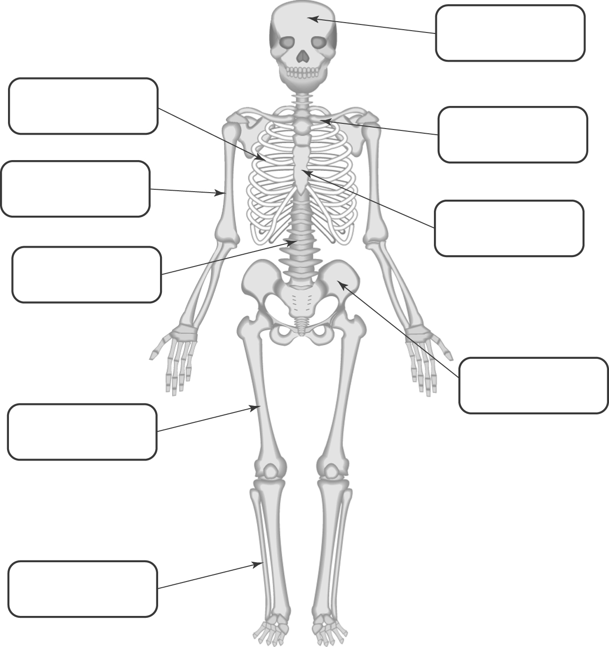

Joints
2. Complete the following table by inserting the correct term for the type of joint in the first column.
Types: hinge pivot ball and socket
Type of joint | Movement of the joint
 | Allows movement in many different directions
 | Allows movement in only one direction
 | Allows twisting movements

Joints, bones and muscles
3. Consider the diagram below of the arm and shoulder.
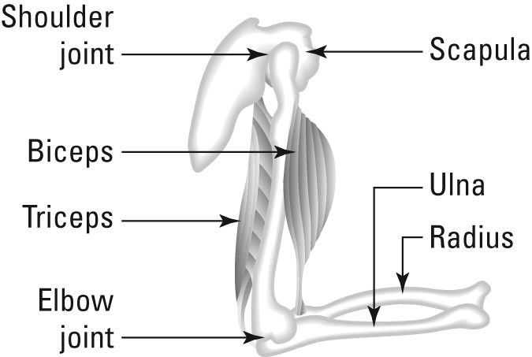 | (a) Identify the types of joints in this diagram.  (b) Explain how the forearm can be raised and lowered via the combined action of the two muscles and the elbow joint.

